***Test-1:*** User enters invalid data for co-ordinates

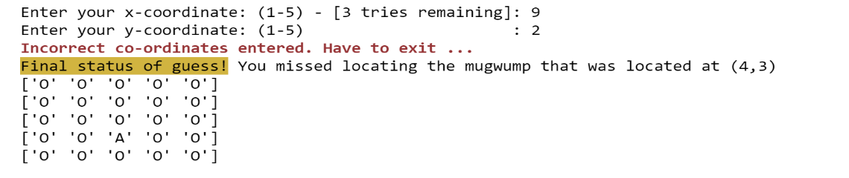

***Test-2:*** User enters co-ordinates that are correct match

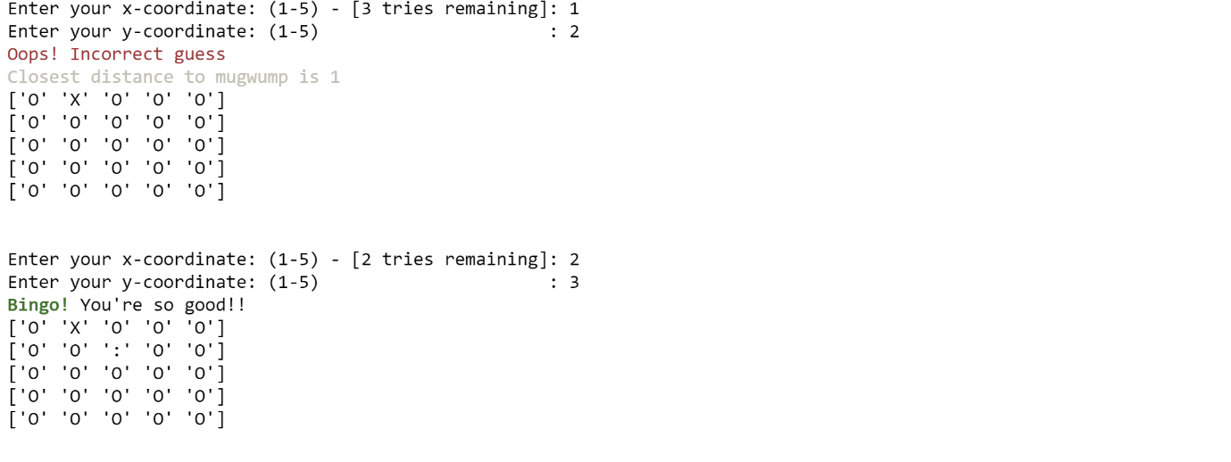

***Test-3:*** User fails to enter correct co-ordinates in all his allowed 3 tries. Also, repeats the same co-ordinate again.

